NCMC Tennis at Fulton on Sept. 20
8:00 a.m. Coaches Meeting
Location of the seed meeting will be at the athletic complex field house.
(Discussing seeds, NCMC changes, All conference)
9:00 a.m. Singles @ Fulton
Doubles @ Westminster
See Brackets for matches and times

Westminsters College Courts
501 Westminster Ave, Fulton MO
PARK AT SOFTBALL FIELD on 7th St.

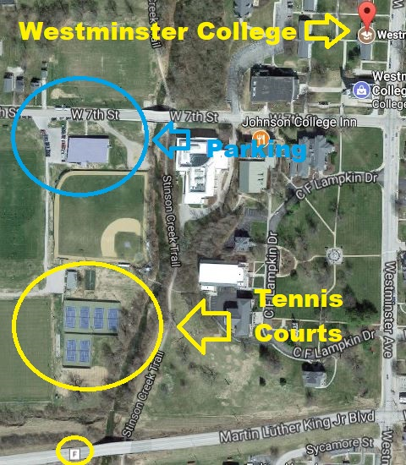

Fulton High School Courts
1 Hornet Dr. Fulton MO. 65251
Park Buses in Gravel lots near student parking.

